Tiny13 Design Idea

Hi Freaks.

Have a gawk at this circuit Here. Interesting, but there’s a much better way of accomplishing and even exceeding this functionality.

Check this chip out. The TCS230 is ideally suited for use when one needs a Red Green Blue digital output, corresponding to the ambient color intensity.

The schematic below shows how easy it is to interface this chip to our old trusty Tiny13 and the software is just as easy to understand, particularly if you’ve been following the Tiny13 Design Idea series so far.

As you can see the main part of the routine concerns itself with measuring the
period of the 50% Duty cycle square wave of Pin 6 OUT. This is connected to the
interrupt pin of the Tiny13 on Pin 6 INT0 and the resultant Light value proportional period count is stored in CntHi … CntLo. We use a TXCO 13 Mhz GSM Phone Xtal as the time base frequency since they are extremely accurate and stable and can be stripped from an old Cell Phone for as little as 50 Cents.

In this application we set the TCS230 chip to run in 100% mode while the Tiny13
clocked @ 13 Mhz can easily handle all the likely output frequencies between
2 Hz ( Full Darkness ) and 600 Khz ( Mega Bright ) by simply counting the Period of the 50% duty cycle waveform.

For more info, ask and you shall receive.
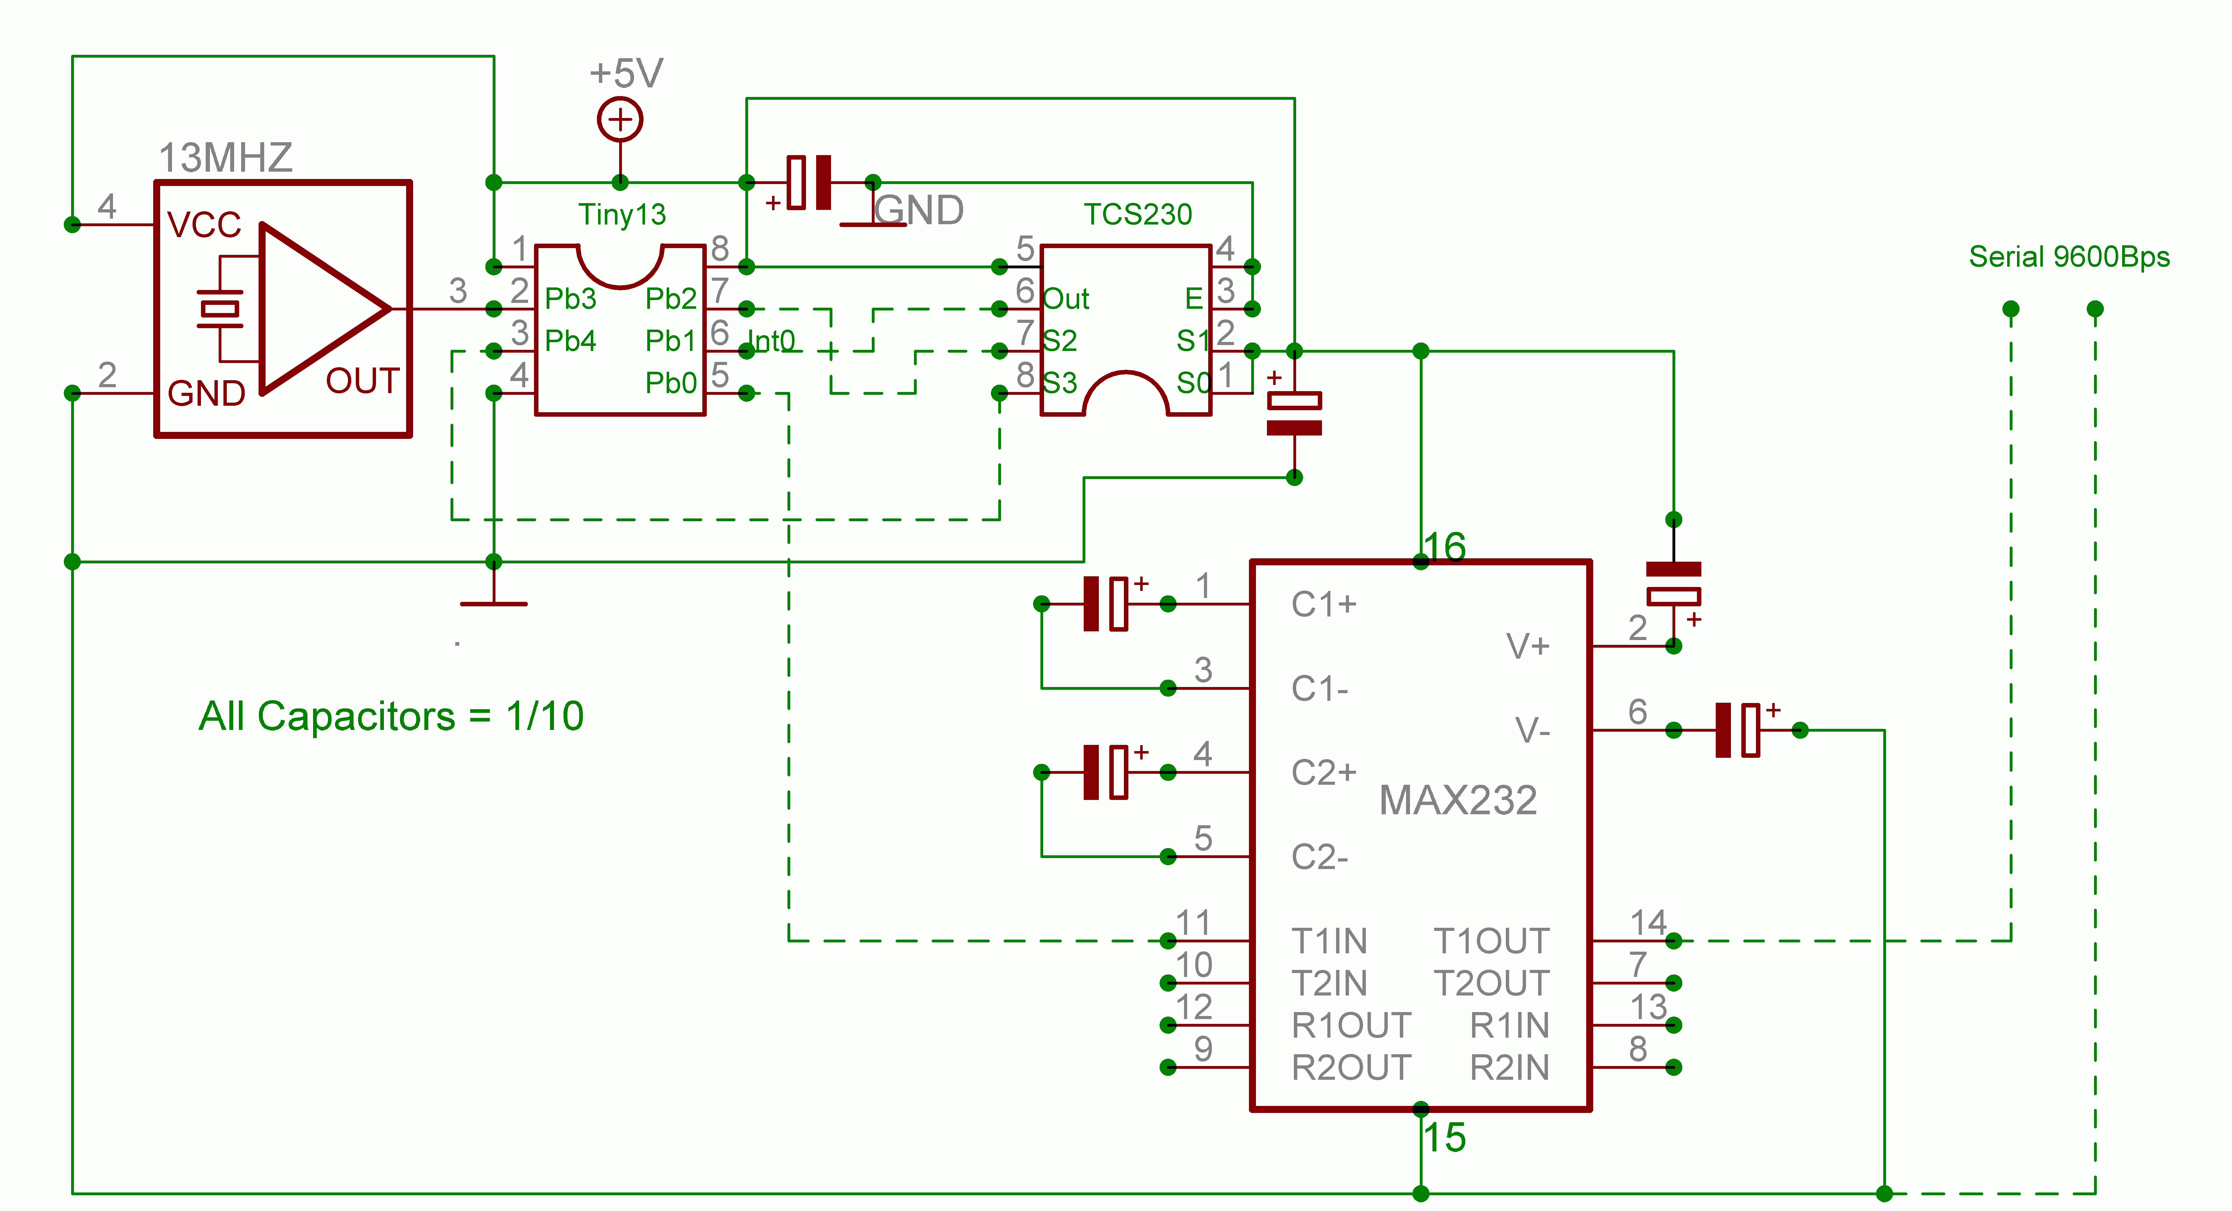

Let there be light ????

John-Alfred Ullasmann

